USER INTERFACE AND DESIGN
Experiment -2
NAME: ABINASH G ROLL NO:240701007

Design a UI where users recall visual elements (e.g., icons or text chunks). Evaluate the effect of chunking on user memory.
FRAME 1:
INSTRUCTION PAGE:
Chunking Analysis of the Instruction Page
Chunking is a cognitive strategy that breaks down information into smaller, manageable units, making it easier to process and retain. The Memory Recall Task instruction page effectively utilizes chunking in the following ways:

1. Clear and Sequential Numbering
• The instructions are divided into six clear steps, making them easy to understand and follow.
• Each step focuses on a single action, helping users process information without confusion or overload.

2. Logical Grouping of Information
• Observation Phase (Steps 1–2) → Introduces users to what they will see on the screen.
• Memorization Strategy (Step 3) → Encourages users to concentrate on remembering the displayed items.
• Recall Phase (Steps 4–5) → Explains how and when users must recall the items.
• Key Performance Metric (Step 6) → Emphasizes that accuracy is more important than speed.

3. Visual Hierarchy and Design Elements
• Large and bold title ("MEMORY RECALL TASK") → Clearly communicates the task objective.
• Proper spacing and bullet-point instructions → Improve readability and reduce visual clutter.
• Clearly visible “START” button → Guides users to proceed to the next stage of the task.
• Panda-themed visuals and bamboo graphics → Create a friendly, engaging atmosphere without distracting from the instructions.

4. Time Constraint Reinforcement
• Step 5 clearly mentions, “You will have 3 seconds to view the items.”
• This prepares users for the limited viewing time and encourages focused attention.

5. Simplicity and Clarity
• Instructions are written using short, simple sentences for easy comprehension.
• The use of active voice keeps the content direct, clear, and user-friendly.

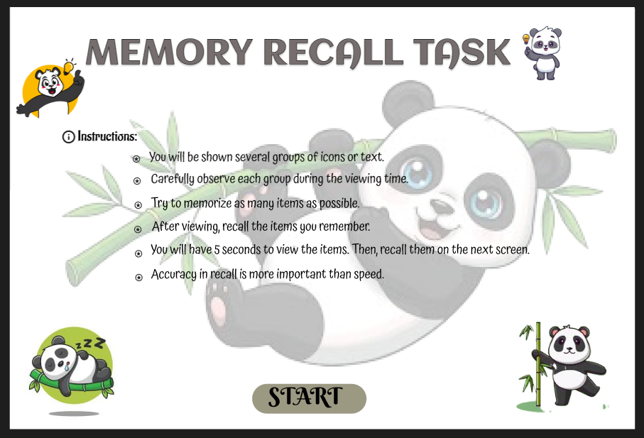

FRAME 2:
CHUNKING PHASE:
Analysis of the Memory Recall Task – Chunking Phase Screen
This screen represents the Chunking Phase of a Memory Recall Task, where users observe and memorize a set of icons within a limited time. The Panda-themed interface applies chunking principles to support effective visual memory encoding. The key components are explained below:

1. Purpose of the Screen
• This screen serves as the visual memory encoding phase, where users carefully observe and mentally group items before recall.
• The label “Chunking Phase” clearly indicates that the task encourages users to apply chunking strategies to improve memory performance by organizing information into meaningful groups.

2. Key Elements and UI Components
⏳ Countdown Timer (Top Left – Circular Indicator)
• Indicates a limited viewing time of 3 seconds, prompting users to focus and memorize quickly.
• The bright colour and prominent placement draw attention and create a sense of urgency.
🟪 Progress Bar (Below the Title)
• Visually represents the remaining time during the chunking phase.
• Reinforces time awareness and helps users pace their observation.
🔲 Grid of Icons (Panda-Themed Tiles)
• Displays multiple panda-related icons arranged in a structured grid format.
• Icons include variations such as pandas holding bamboo, pandas sitting, pandas with hearts, and pandas eating.
• These icons encourage chunking through:
o Grouping by character similarity (different panda poses).
o Grouping by object association (bamboo, food, hearts).
o Recognizing repeated patterns and icons across the grid.
🐼 Panda Mascot and Motivational Text
• A friendly panda character appears on the screen, enhancing user engagement.
• The message “Remember now, recall later!” provides clear cognitive guidance without distraction.

3. How the Chunking Phase Works
- Users scan the grid to identify patterns, repetitions, and similarities among panda icons.
- The limited time forces users to form quick mental chunks rather than memorizing individual items.
- After the timer ends, users move to the recall phase, where they must identify or remember the previously shown icons.

4. Cognitive and UX Benefits of Chunking
• Improves short-term memory by enabling recall of grouped information instead of isolated elements.
• Reduces cognitive load by organizing visual data into meaningful categories.
• Enhances pattern recognition, leading to more accurate and efficient recall.
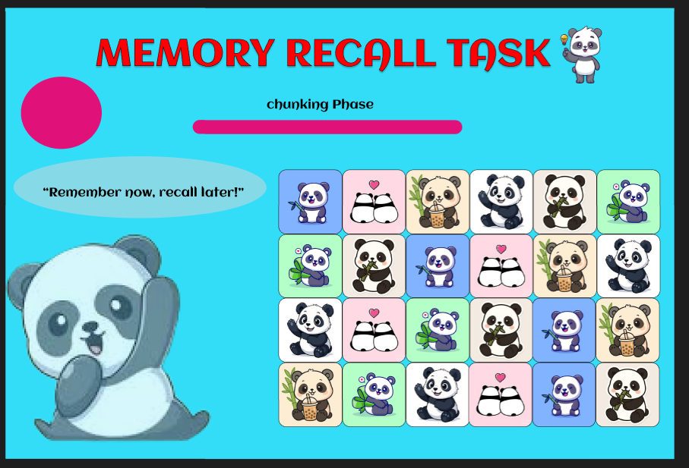

FRAME 3:
RECALL PHASE:
Analysis of the Memory Recall Task – Selection Phase
This screen represents the Selection Phase of a Memory Recall Task, where users recall and select the items they remember from the previous Chunking Phase. The Panda-themed interface maintains consistency while testing short-term memory accuracy. The key components are described below:

1. Purpose of the Screen
• This is the memory retrieval stage, where users identify and select the items they remember seeing during the Chunking Phase.
• The primary goal is to evaluate the effectiveness of chunking and the user’s short-term memory retention.

2. Key Elements and UI Components
📝 Title & Instructions
• “MEMORY RECALL TASK” (Bold Header) – Clearly reinforces the purpose of the activity.
• “Select the items you remember:” – Provides direct and unambiguous guidance to the user.
🟪 Grid of Icon Choices (Panda-Themed Icons)
• A set of panda-related icons is displayed as multiple-choice options.
• Some icons were shown in the Chunking Phase, while others act as distractors.
• Users must distinguish previously seen panda icons from new ones.
• Each icon includes a radio button below it for selection.
🐼 Panda Mascot (Bottom Left)
• The panda character adds a friendly and playful element to the interface.
• Maintains thematic consistency across all phases of the task and enhances user engagement.
🟪 “SUBMIT” Button (Bottom Centre)
• Allows users to confirm their selected answers after completing the recall process.
• Clearly positioned to guide users toward task completion.

3. How the Selection Phase Works
- Users examine the displayed panda icons and recall which ones appeared in the Chunking Phase.
- They select the remembered icons using the radio buttons provided below each option.
- The presence of distractor icons tests the accuracy of the user’s memory.
- Clicking the “SUBMIT” button finalizes the selections and transitions to a feedback or result screen.

4. Cognitive and UX Benefits
• Evaluates memory accuracy by comparing user selections with previously displayed items.
• Uses distractors to measure the user’s ability to differentiate true memories from false ones.
• Simple selection mechanism (radio buttons) ensures ease of use and clarity.
• Gamified visuals and the panda theme increase engagement and reduce task-related stress.
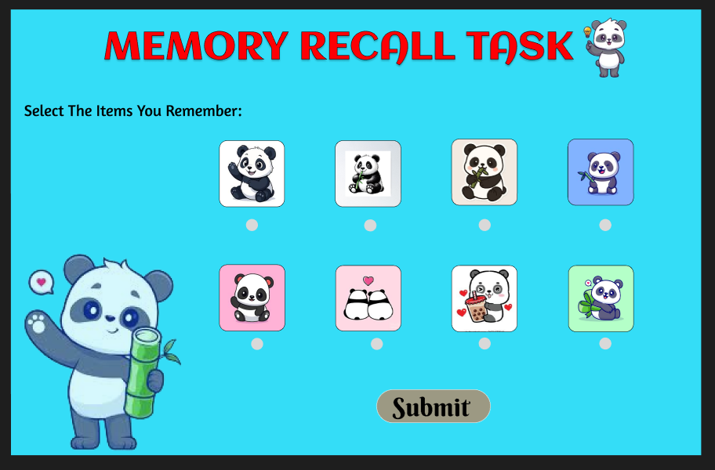
FRAME 4:
RESULT PAGE:
Analysis of the Memory Recall Task – Score & Feedback Screen
This screen represents the Score & Feedback Phase of the Memory Recall Task, where users receive feedback on their performance based on the selections made during the previous Recall Phase. The Panda-themed design maintains consistency while clearly communicating results and next actions.

1. Purpose of the Screen
• Provides feedback on the user’s recall accuracy by displaying the final score.
• Allows users to decide their next step, such as continuing, restarting, or exiting the task.

2. Key Elements & UI Components
📝 Title & Score Display
• “MEMORY RECALL TASK” – Reinforces the overall task title and maintains consistency across all screens.
• Score Display (“3/5”) – Clearly shows the number of correct responses out of the total attempts.
• The large, bold score presentation ensures immediate visibility and understanding of performance.
🟪 Action Buttons (Right Side)
- “Continue” – Allows the user to proceed to the next level or task.
- “Restart” – Enables the user to repeat the memory recall activity to improve performance.
- “Exit” – Allows the user to leave the task or application.
🐼 Panda-Themed Visual Elements
• A panda character and bamboo graphics add a friendly, calming, and playful atmosphere.
• These visuals reduce stress often associated with performance evaluation and enhance user engagement.

3. How This Phase Works
- The system evaluates the user’s selections made during the Recall Phase.
- It calculates the final accuracy score (shown here as 3/5) and displays it prominently.
- Users review their performance and choose their next action:
o Continue to move forward.
o Restart to attempt the task again.
o Exit to end the session.

4. Cognitive & UX Benefits
• Immediate feedback helps users understand their memory performance clearly.
• Multiple action choices give users control over their learning and interaction flow.
• The panda-themed, gamified design makes feedback less intimidating and more engaging.

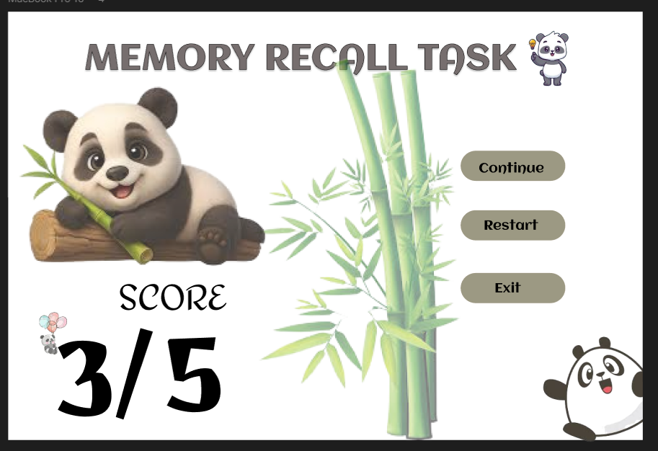
PROTOTYPE LINK:
https://www.figma.com/proto/Sjm6dwnHkTgUQrGHFbMmOa/Untitled?node-id=30-26&t=2SllGZwGpigDDgm5-1&scaling=scale-down&content-scaling=fixed&page-id=0%3A1&starting-point-node-id=127%3A52&show-proto-sidebar=1

